**TOURIST CAMP SITE RECOMMENDATION SYSTEM**

**SEMINAR-1 PROJECT REPORT**

***Submitted by***

**PRAWIN R.P – RA2011026020107**

**HARI NARAYANAN S – RA2011026020110**

**SANTHOSH KUMAR R – RA2011026020111**

Under the guidance of

**Mrs. P. Preethy Jemima, M.E.,**

# (Assistant Professor, Department of Computer Science and Engineering)

***In partial fulfillment for the award of the degree***

***of***

# BACHELOR OF TECHNOLOGY

***in***

# COMPUTER SCIENCE AND ENGINEERING WITH SPECIALISATION IN ARTIFICIAL INTELLIGENCE AND MACHINE LEARNING

***of***

# FACULTY OF ENGINEERING AND TECHNOLOGY



**SRM INSTITUTE OF SCIENCE AND TECHNOLOGY RAMAPURAM CAMPUS, CHENNAI-600089**

# NOV 2022

**SRM INSTITUTE OF SCIENCE AND TECHNOLOGY**

(Deemed to be University Under Section 3 of UGC Act, 1956)

**BONAFIDE CERTIFICATE**

Certified that the Seminar-I report titled “**TOURIST CAMP SITE RECOMMENDATION SYSTEM**” the bonafide work of **PRAWIN R.P [RA2011026020107], HARI NARAYANAN S [RA2011026020110]** and **SANTHOSH KUMAR R [RA2011026020111]** submitted for the course 18CSP103L Seminar – I. This report is a record of successful completion of the specified course evaluated based on literature reviews and the supervisor. No part of the Seminar Report has been submitted for any degree, diploma, title, or recognition before.

## SIGNATURE SIGNATURE

Mrs. P. Preethy Jemima, M.E., Dr. K. RAJA, M.E., Ph.D.,

Assistant Professor Professor and Head

Computer Science & Engineering Computer Science & Engineering

SRM Institute of Science and Technology SRM Institute of Science and Technology

Ramapuram, Chennai. Ramapuram, Chennai.

Submitted for the Seminar-1 Viva Voce Examination held on at SRM Institute

of Science and Technology, Ramapuram Campus, Chennai-600089.

## EXAMINER 1 EXAMINER 2

**SRM INSTITUTE OF SCIENCE AND TECHNOLOGY, RAMAPURAM, CHENNAI – 89**

**DECLARATION**

We hereby declare that the entire work contained in this project report titled **TOURIST CAMP SITE RECOMMENDATION SYSTEM** has been carried out by **PRAWIN R.P [RA2011026020107], HARI NARAYANAN S [RA2011026020110], and SANTHOSH KUMAR R [RA2011026020111]** at SRM Institute of Science and Technology, Ramapuram Campus, Chennai - 600089, under the guidance of Mrs.P Preethy Jemima, Assistant Professor, Department of Computer Science and Engineering.

Place: Chennai Date:

|  |  |  |
| --- | --- | --- |
| PRAWIN R.P | HARI NARAYANAN S | SANTHOSH KUMAR R |
| RA2011026020107 | RA2011026020110 | RA2011026020111 |

# ABSTRACT

This project  will play an essential role in making decisions like choosing a campground. This system heavily relies on individuals voluntarily submitted reviews to build the reputation for nearby businesses.

Unfortunately, the reviews expose user(s) private information such as visited places to the public and adversaries. Even worse, such location information is usually public because it is that the basic information of companies , and adversaries might be anyone starting from advertisement spammer to physical stalker.

This website formalizes the privacy preserving problem in campground review systems. The framework can preserve users’ location privacy in arbitrary local area and may maintain an honest utility for both the system and each user.

We evaluate our framework towards real-world data traces. The results validate that the framework are able to do an honest performance. The user can post the review for campgrounds which can be public can be viewed by registered users.

People really interested in hiking and travelling in hill stations are really finding many challenges in finding a good campsite in a perfect ambiance with a safe environment. Searching for a good campsite plays an important primary key factor for the trekkers , hikers and for the tourists.

This site uses the feedback of the people already visited a specific camp to make easier decisions for other campers who can choose the camping spots based on these feedback from other people.

Camping site recommendation systems are created, according to emulate a travel page to provide suggestions and tourist information to facilitate the decision-making process.

The feedback and the reviews from the people who already visited that particular campsite , using these the site make easy decision and recommends for the other campers who searching for the best camping spots. The user data interaction in this website will be the input attributes for the recommendation model and based on those attributes the recommendation model lists a campsites name with location in the website.

# TABLE OF CONTENTS

|  |  |  |
| --- | --- | --- |
| **SR.**  **NO.** | **CONTENTS** | **PAGE NO.** |
| **1.** | **INTRODUCTION**   * 1. Introduction      1. Problem Statement   2. Aim of the Project   3. Project Domain   4. Scope of the Project   5. Methodology |  |
| **2.** | **LITERATURE SURVEY** |  |
| **3.** | **PROJECT DESCRIPTION**   * 1. Existing System   2. Proposed System   3. Feasibility Study   4. System Specification |  |
| **4.** | **MODULE DESCRIPTION**   * 1. General Architecture   2. Design Phase      1. Data Flow Diagram      2. UML Diagram      3. Use Case Diagram      4. Sequence Diagram      5. Communication Diagram      6. Activity Diagram      7. Block Diagram   3. Module Description |  |

**TABLE OF CONTENTS**

|  |  |  |
| --- | --- | --- |
| **SR.**  **NO.** | **CONTENTS** | **PAGE NO.** |
| **5.** | **IMPLEMENTATION AND TESTING**   * 1. Input and Output   2. Testing   3. Sample Codes   4. Test Results |  |
| **6.** | **RESULTS AND DISCUSSIONS**  6.1 Efficiency of the Proposed System |  |
| **7.** | **SOURCE CODE & POSTER PRESENTATION**   * 1. Sample Code   2. Poster Presentation |  |
| **8.** | **CONCLUSION AND FUTURE ENHANCEMENTS**   * 1. Conclusion   2. Future Enhancements |  |
| **9.** | **REFERENCES** |  |

# CHAPTER 1 INTRODUCTION

## INTRODUCTION

## This is an internet application designed to feature , rate and review different campgrounds, different users(read campers) can put in their comments and concerns, in order that it's a well informed and well prepared camping This app contains API secrets and passwords that have been hidden deliberately, so the app cannot be run with its features on your local machine.

## In order to review or create a campground, you want to have an account. pass real time data to a long distance. For this we use an open-source board ESP 32 to create a seamless Mesh network which send, receive and propagate data collected from various sensors to all its node.

## This is a website where users can create and review campgrounds. In order to review or create a campground, you want to have an account. This project was designed using Node.js, Express, MongoDB, and Bootstrap, was used to handle authentication.

## The Login Feature gives the user right to login to the website after creation of the account successfully for the website. The login process is on high priority.

## During the login process the user needs to put the User id and Password in order to access the website contents. Whenever the user gets logged-in to the website he/she will be directed to the Home page.

## This website is an CRUD operation based , were ways one can operate on stored data. It is a mnemonic for the four basic functions of persistent storage. CRUD typically refers to operations performed in a database or datastore, but it can also apply to higher level functions of an application such as soft deletes where data is not actually deleted but marked as deleted via a status.

## The acronym for CRUD is (Create, Read, Update, Delete). Here the user can able to create a new campsite entries (Create), able to search for the campsites (Read), update them (Update) and delete the entries that they have made previously (Delete).

## PROBLEM STATEMENT

Automatic vehicle license plate detection and recognition is a key technique in most of traffic related applications and is an active research topic in the image processing domain. Different methods, techniques and algorithms have been developed for license plate detection and recognitions.

People really interested in hiking and travelling in hill stations are really finding many challenges in spotting a good campsite in a perfect ambiance with a safe environment. Searching for a good campsite plays an important primary key factor for the trekkers , hikers and for the tourists.

Their interest in camping get to camping spots by difficulties and find it being over crowed or polluted by other campers. This site uses the feedback of the people already visited a specific camp to make easier decisions for other campers who can choose the camping spots based on these feedback from other people. This site the reviews and ratings from the people who pre visited that particular campsite , using these the site make easy decision and recommends for the other campers who searching for the best camping spots.

* 1. **AIM OF THE PROJECT**

The main aim and the objective of this project is to create a website for reviewing campgrounds by using the data of users such as their geographic location to gather information about the campgrounds they have visited. This data is stored as per each user. The user can post the review for campgrounds which can be public can be viewed by registered users. Based on the reviews, ratings and the locality, user gets recommended a list of campsites. One of the major aspect of the website is to keep the data of the user private. This website is packed with security features to meet the expectations of privacy and security.

* 1. **PROJECT DOMAIN**

The domain of the project is Web Development. This project is a full stack website which is Development of both front end (client side) and back end (server side) portions of web application. They work on the frontend, backend, database and debugging of web applications or websites. This website is an CRUD operation based, were ways one can operate on stored data**.** It is a mnemonic for the four basic functions of persistent storage. Here the user can able to create a new campsite entries, able to search for the campsites, update them and delete the entries that they have made previously.

Machine Learning plays a major role in recommendation system in this full stack website. Here it is going to be a supervised machine learning algorithm for recommendation system, where the user data

Interaction in this website will be the input attributes for the recommendation model and based on those attributes the recommendation model lists a campsites name with location in the website interface.

## SCOPE OF THE PROJECT

The number of choices for anything on internet is very high and it’s tedious to refine most wanted data by self while searching. The scope of this proposal system includes working within numerous data, with ease.

Many people have problem selecting the alternative  camp site places due to lack of time and due to search issues. Also tourist camp site recommendations from friends can be time consuming. The system helps in saving lots of time. Here through this website it is ease to search for a campsite and get recommended a list of campsites in a virtual way.

Many mobile phone and limited processing power computers can’t handle recommendation system due to its extremely large dataset. The solution opted for this can be use of web services. The proposed system uses web services, thus makes process simpler.

## METHODOLOGIES

The proposed methodology consists of the following phases:

* When we are provided with user’s data, we store it in a database. To retrieve the data and extract information we need an API that helps in establishing connection between client and the server.

* REST leverages the capabilities of Hypertext Transfer Protocol (HTTP) and Uniform Resource Identifiers (URIs) to retrieve or modify the state of a resource.

* It works by fielding requests for a resource and returning all relevant information about the resource, translated into a format that clients can easily interpret.

# CHAPTER 2 LITERATURE SURVEY

## Paper – I

**Title:** Influential Factors for Tourist Profiling for Personalized Tourism Recommendation Systems

**Authors:** Maryam Kamal , Ioannis Chatzigiannakis

**Methodology:** The main objective is to present an up-to-date, thorough and compact survey on Tourism Recommendation Systems and the most influential factors which significantly impacts the decision-making of tourists while planning a tour.

**Technical Gap:** Single personalized recommendation method and no deeper data analysis

**Description:** This paper discusses the application of recommendation systems for the domain of tourism. In this paper, we aim to present an up-to-date, thorough and compact survey on Tourism Recommendation Systems and the most influential factors which significantly impacts the decision-making of tourists while planning a tour.

## Paper – II

## Title: Travel Recommendation System Using Content and Collaborative Filtering - A Hybrid

# Approach

# 

# Authors: Vyshnavi Garipelly , Padma Teja Adusumalli , Priyanka Singh

**Methodology:** In this paper, we are proposing a hybrid approach of recommended systems to recommend tourist attractions for users, combination of both content and collaborative filtering approach.

**Technical Gap:** Privacy Concerns

**Description:** This Hybrid approach avoids the disadvantages in both the methods and provides users with accurate information. We have applied a model-based collaborative filtering approach called SVD for better results. The weighted hybridization approach is used to combine the results of both methods. The data of tourist attractions and users have been collected for implementation.

## Paper – III

## Title: Research on E-Commerce Personalized Recommendation System based on Big Data Technology

**Authors:** Zhen Wang , Allam Maalla , Mingbiao Liang

**Methodology:** To collect and pre-process data in real-time from multiple e-commerce platforms which generate user data and gather all the personalized data of the users to prepare for the next data mining.

**Technical Gap:** Quality depends on huge historical data-set and issues like and no deeper data analysis

**Description:** The core idea is to collect and pre-process data in real-time from multiple e-commerce platforms which generate user data and gather all the personalized data of the users to prepare for the next data mining, then use the data mining technology in the big data to recommend personalizing products automatically, so that it can satisfy the personalized requirements of users.

**Paper – IV**

## Title: E-Commerce Intelligent Recommendation System

**Authors:** [Nitesh Bharti, Mohit Kumar,](https://ieeexplore.ieee.org/author/37088842373) [V. M. Manikandan,](https://ieeexplore.ieee.org/author/37088842373) [Y. Deepika](https://ieeexplore.ieee.org/author/37088842373)

**Methodology:** In this research paper, With the popularity of smart phones, e-commerce has developed rapidly. Intelligent recommendation is a very important task in the field of e-commerce. This paper mainly studies e-commerce intelligent recommendation system(IRS) based on deep learning.

**Technical Gap:** New user problem, New item problem, Input of utility function by the user.

**Description:** This paper mainly studies e-commerce intelligent recommendation system(IRS) based on deep learning. In this paper, the overall design of e-commerce recommendation system is firstly carried out, and the functional modules and system architecture of e-commerce IRS are proposed. Then, this paper discusses the recommendation algorithm in the e-commerce IRS, and optimizes the e-commerce IRS based on convolutional neural network.

## Paper – V

**Title:** Research and implementation of movie recommendation system

**Authors:** Qian Chen; Jiacheng Qin

**Methodology:** As one of the important means to alleviate the information overload problem, the recommendation system can help users find their favorite movie content quickly and bring them a good experience, so it is widely used in famous movie and video websites at home and abroad, and has brought great commercial value.

**Technical Gap:** Handle the huge data and process them**.**

**Description:** In this paper, we introduce the recommendation system and recommendation algorithm, improve the ConvMF model based on deep learning, verify and analyze the experimental results, and finally complete the design of movie recommendation subsystem.

**Paper – VI**

## Title: An Intelligent Data Analysis for Hotel Recommendation Systems using Machine Learning

## Authors: Bushra Ramzan , Imran Sarwar Bajwa , Noreen Jamil , Farhaan Mirza

**Methodology:** This paper presents an intelligent approach to handle heterogeneous and large-sized data using machine learning to generate true recommendations for the future customers.

**Technical Gap:** Information causes overload problems which in turn are time consuming and affects

the overall performance

**Description:** This paper presents an intelligent approach to handle heterogeneous and large-sized data using machine learning to generate true recommendations for the future customers. The Collaborative Filtering (CF) approach is one of the most popular techniques of the RS to generate recommendations.

# CHAPTER 3 PROJECT DESCRIPTION

## EXISTING SYSTEM

Currently in many sectors camp siting places is identified using the people who visited which is manually noted by a human which is a slow process. People interested in camping get to camping spots by difficulties an find it being over crowed or polluted by other campers. Thus, the existing system is an intensive manual process which can perhaps be automated using machine learning which forms the basis of this project.

## PROPOSED SYSTEM

Camp site acts as a recommendation system. Users can send data and acquire data using the system. There is no need to store the data manually and it can be done virtually. The data is collected and then stored in easily extractable format. This website is an CRUD operation based, were ways one can operate on stored data**.** It is a mnemonic for the four basic functions of persistent storage. Here the user can able to create a new campsite entries, able to search for the campsites, update them and delete the entries that they have made previously.

Thanks to the need to store the data for a short while, camp site data can provide both alibis and incriminating data. camp site also provides security on a lower level, such as moderation to ensure that no heavy sided reviews are being commented.

Each branch out of the seven branches represents a specialized classifier for a character that resides on a specific  review of a camp site place. This work was very helpful because the possible errors generated in the algorithm step can be minimized and end-to-end support can also be provided.

We have added additional features to ensure that the camp site is publicized to the audience and events are conducted to promote the camp site.

The data is encrypted and cannot be easily accessed by third party users. Authentication is required to access the camp site and we have also improved the efficiency of the algorithm. The proposed system works on a much efficient level compared to other systems.

## FEASIBILITY STUDY

A Feasibility study is carried out to check the viability of the project and to analyze the strengths and weaknesses of the proposed system. A feasibility study is a detailed analysis that considers all the critical aspects of a proposed project to determine the likelihood of it succeeding.

Although feasibility studies can help project managers determine the risk and return of pursuing a plan of action, several steps should be considered before moving forward. Detailed investigation has really helped in knowing the feasibility of various Software and hardware components as well as the overall project model in terms of technical, operational, and economical respects. Thus, this project is feasible in all respect.

The feasibility study is carried out in three forms:

## Economic Feasibility

The proposed system does not require any high-cost equipment. This project can    be developed within the available software. This assessment typically involves a cost/ benefits analysis of the project, helping organizations determine the viability, cost, and benefits associated with a project before financial resources are allocated. It also serves as an independent project assessment and enhances project credibility—helping decision-makers determine the positive economic benefits to the organization that the proposed project will provide.

## Technical Feasibility

The main tools used in this project are Anaconda prompt, Visual studio, Jupyter Notebook, and the language used to execute the process in Python, Javascript. This assessment focuses on the technical resources available to the organization. It helps organizations determine whether the technical resources meet capacity and whether the technical team can convert the ideas into working systems. Technical feasibility also involves the evaluation of the hardware, software, and other technical requirements of the proposed system.

## Social Feasibility

Social feasibility is a determination of whether project will be acceptable or not. our project is Eco-friendly for society and there are no social issues. Our project must not be threatened by the system instead must accept it as a necessity. This assessment investigates whether any aspect of the proposed project conflicts with legal requirements like zoning laws, data protection acts or social media laws. Let’s say an organization wants to construct a new office building in a specific location. A feasibility study might reveal the organization’s ideal location isn’t zoned for that type of business. That organization has just saved considerable time and effort by learning that their project was not feasible right from the beginning.

## SYSTEM SPECIFICATIONS

* + 1. **HARDWARE SPECIFICATIONS**

|  |  |
| --- | --- |
| PROCESSOR | Intel i5-8250 @ 3.40GHz |
| STORAGE | 512 GB SSD |
| RAM | 16 GB |
| GPU | Nvidia GTX 1650 Ti |
| OPERATING SYSTEM | Windows 11 x64 Bit |

## SOFTWARE USED

|  |
| --- |
| Windows 10, 11 |
| Anaconda Jupyter Notebook |
| Python , GIT , HTML , Javascript and its Frameworks |
| Machine Learning Modules |

# CHAPTER 4 MODULE DESCRIPTION

## GENERAL ARCHITECTURE

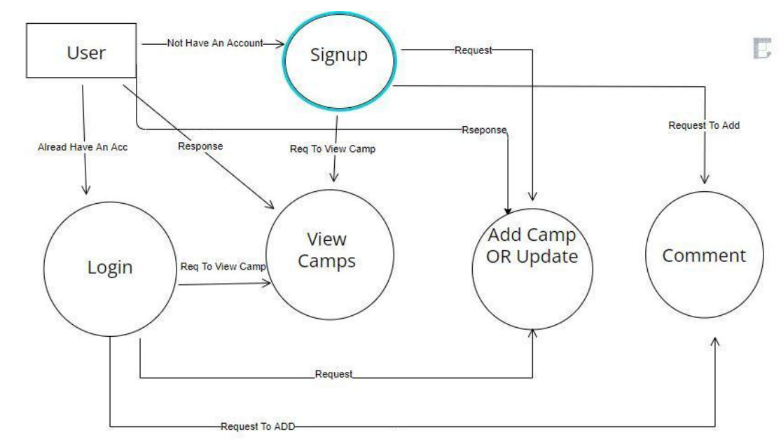

**Figure 4.1: Architecture Diagram**

## The system goes through the ways one can operate on stored data. It is a mnemonic for the four basic functions of persistent storage. CRUD typically refers to operations performed in a database or datastore, but it can also apply to higher level functions of an application such as soft deletes where data is not actually deleted but marked as deleted via a status. Here the user can able to create a new campsite entries (Create), able to search for the campsites (Read), update them (Update) and delete the entries that they have made previously (Delete).

## DESIGN PHASE

* + 1. **DATA FLOW DIAGRAM**

A Data Flow Diagram (DFD) is a traditional visual representation of the information flows within a system. It shows how data enters and leaves the system, what changes the information, and where data is stored. It can be manual, automated, or a combination of both.

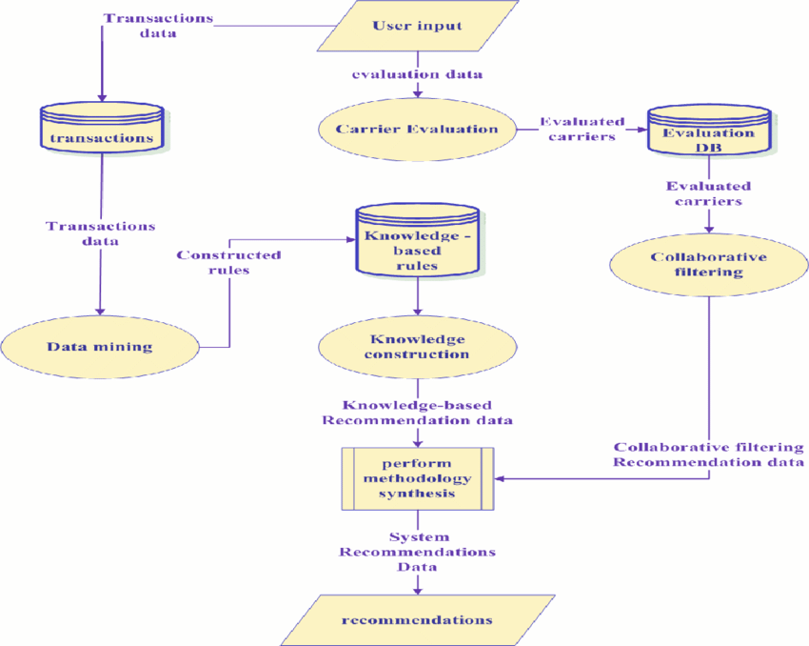

## Figure 4.2: Data Flow Diagram

* + 1. **UML DIAGRAM**

A UML diagram is a diagram based on the UML (Unified Modelling Language) with the purpose of visually representing a system along with its main actors, roles, actions, artifacts, or classes, to better understand, or document information about the system.

UML is a way of visualizing a software program using a collection of diagrams. The notation has evolved from the work of Grady Booch, James Rumbaugh, Ivar Jacobson, and the Rational Software Corporation to be used for object-oriented design, but it has since been extended to cover a wider variety of software engineering projects.

Today, UML is accepted by the Object Management Group (OMG) as the standard for modelling software development. UML stands for Unified Modelling Language. UML 2.0 helped extend the original UML specification to cover a wider portion of software development efforts including agile practices.

* + - * Improved integration between structural models like class diagrams and behaviour models like activity diagrams.
      * Added the ability to define a hierarchy and decompose a software system into components and sub-components.
      * The original UML specified nine diagrams; UML 2.x brings that number up to 13. The four new diagrams are called: communication diagram, composite structure diagram, interaction overview diagram, and timing diagram. It also renamed state chart diagrams to state machine diagrams, also known as state diagrams.

UML is a standard modelling **language**, not a **software development process**. UML provides guidance as to the order of a team’s activities,

* specifies what artifacts should be developed,
* directs the tasks of individual developers and the team, and

offers criteria for monitoring and measuring a project’s products and activities.

UML is intentionally **process independent** and could be applied in the context of different processes. Still, it is most suitable for use case driven, iterative and incremental development processes. An example of such process is **Rational Unified Process** (RUP).

For our project we have drawn 5 Diagrams:

## 4.2.3 USE CASE DIAGRAM

A use case diagram is a graphical depiction of a user's possible interactions with a system. A use case diagram shows various use cases and different types of users the system has and will often be accompanied by other types of diagrams as well.

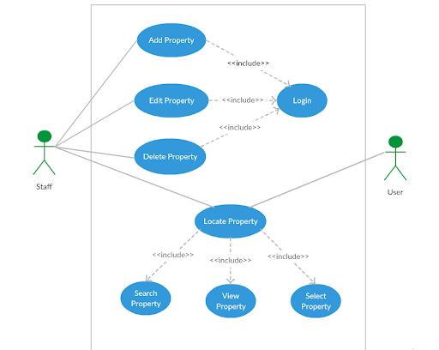

## Figure 4.3: Use Case Diagram

**4.2.4 SEQUENCE DIAGRAM**

Sequence Diagrams are interaction diagrams that detail how operations are carried out. They capture the interaction between objects in the context of a collaboration. Sequence Diagrams are time focus, and they show the order of the interaction visually by using the vertical axis of the diagram to represent time what messages are sent and when.

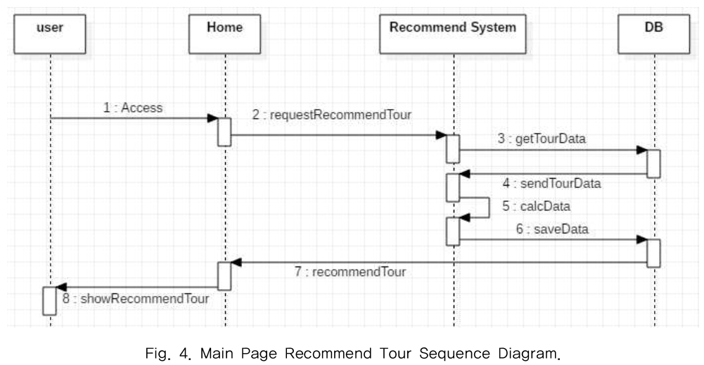

## Figure 4.4: Sequence Diagram

**4.2.5 DEPLOYMENT DIAGRAM**

A deployment diagram is a UML diagram type that shows the execution architecture of a system,

including nodes such as hardware or software execution environments, and the middleware connecting them. Deployment diagrams are typically used to visualize the physical hardware and software of a system. Using it you can understand how the system will be physically deployed on the hardware. Deployment diagrams help model the hardware topology of a system compared to other UML diagram types which mostly outline the logical components of a system.

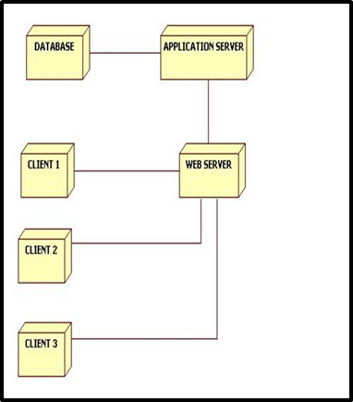

## Figure 4.5: Deployment Diagram

**4.2.6 ACTIVITY DIAGRAM**

Activity Diagrams describe how activities are coordinated to provide a service which can be at different levels of abstraction. Typically, an event needs to be achieved by some operations, particularly where the operation is intended to achieve several different things that require coordination, or how the events in a single use case relate to one another use cases where activities may overlap and require coordination.

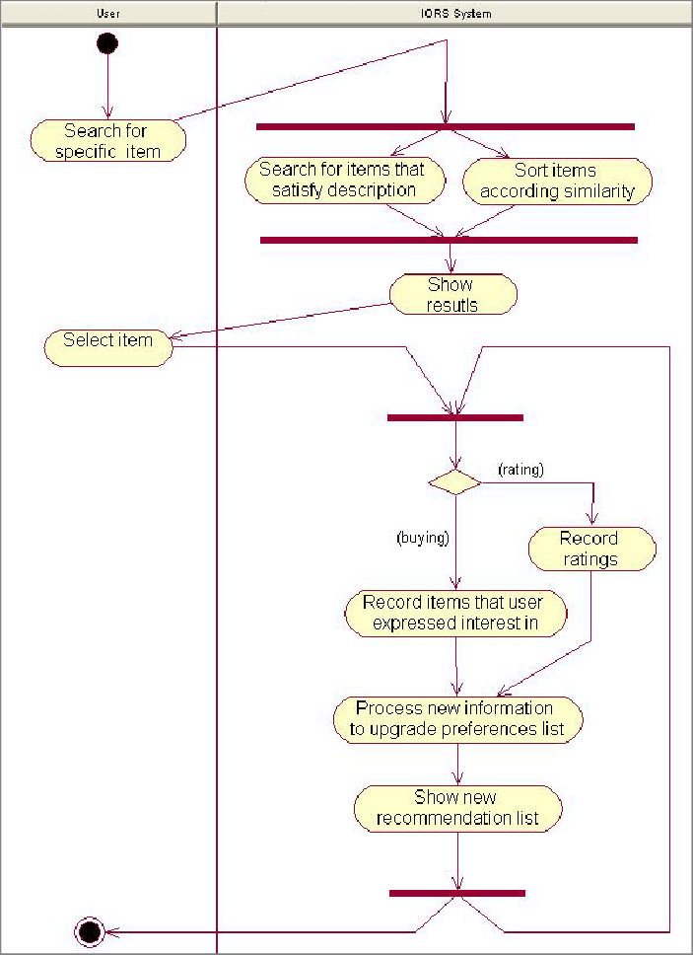

## Figure 4.6: Activity Diagram

**4.2.7 BLOCK DIAGRAM**

A block diagram is a specialized, high-level flowchart used in engineering. It is used to design new systems or to describe and improve existing ones. Its structure provides a high-level overview of major system components, key process participants, and important working relationships. A block diagram is especially focused on the input and output of a system. It cares less about what happens getting from input to output.

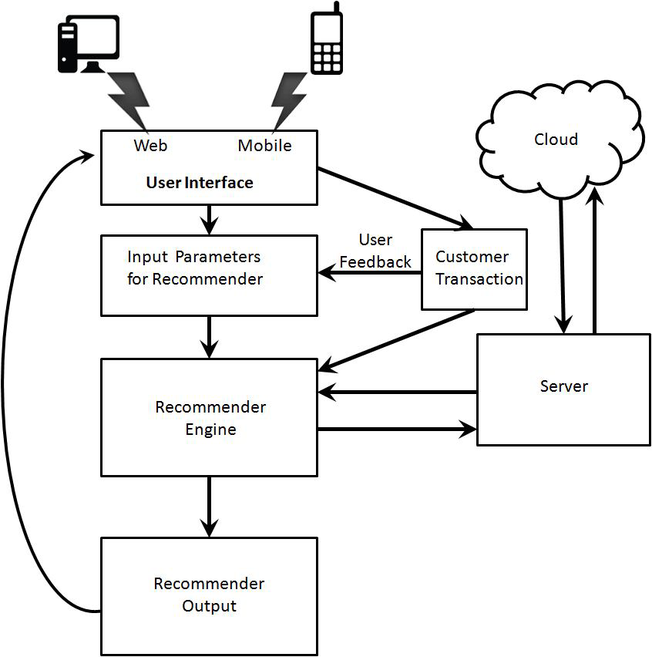

## Figure 4.7: Block Diagram

* 1. **MODULE DESCRIPTION**

Our entire project is divided into six modules:

Step 1: Building Frontend

Step 2: Building Backend

Step 3: Data Collecting

Step 4: Pre Processing of Data

Step 5: Split the data

Step 6: Building the model

Step 7 : testing the model

Step 8 : implementing the model

**4.3.1 BUILDING FRONTEND**

The front end is the part of the website users can see and interact with such as the graphical user interface (GUI) and the command line including the design, navigating menus, texts, images, videos, etc. The part of a website that the user interacts with directly is termed the front end. It is also referred to as the ‘client side of the application. It includes everything that users experience directly.

**4.3.2 BUILDING FRONTEND**

The backend is the server side of the website. It stores and arranges data, and also makes sure everything on the client side of the website works fine. It is the part of the website that you cannot see and interact with. It is the portion of software that does not come in direct contact with the users. The parts and characteristics developed by backend designers are indirectly accessed by users through a front-end application.

**4.3.3 Pre Processing of data**

The Pre-processing section could be a section before the coaching and testing of the info There are four steps within the pre- processing that segmenting data based on reviews, removing data that are not necessary and optimising the data. The collected data could be a vital Pre-processing step in recommendation because of the effectiveness of training model. The next step is to method all the reviews within the data set into an array. reviews is born-again into the array for line them by the loop perform. After that, the image are going to be accustomed Pre- process in- put victimization KNN optimisation and therefore the last step during this section is playacting hot secret writing on labels as a result of several machine learning algorithms cannot operate knowledge labelling directly. They need all input variables and output variables to be numeric, as well as this algorithm. The labelled knowledge are going to be recommended into a numerical label, that the algorithm will perceive it.

**4.3.4 Split the Data**

After the pre-processing part, the information is split into 2 batches, that are training data specifically seventy five percent, and the rest is testing knowledge. every batch is containing each similar reviews and without similar reviews.

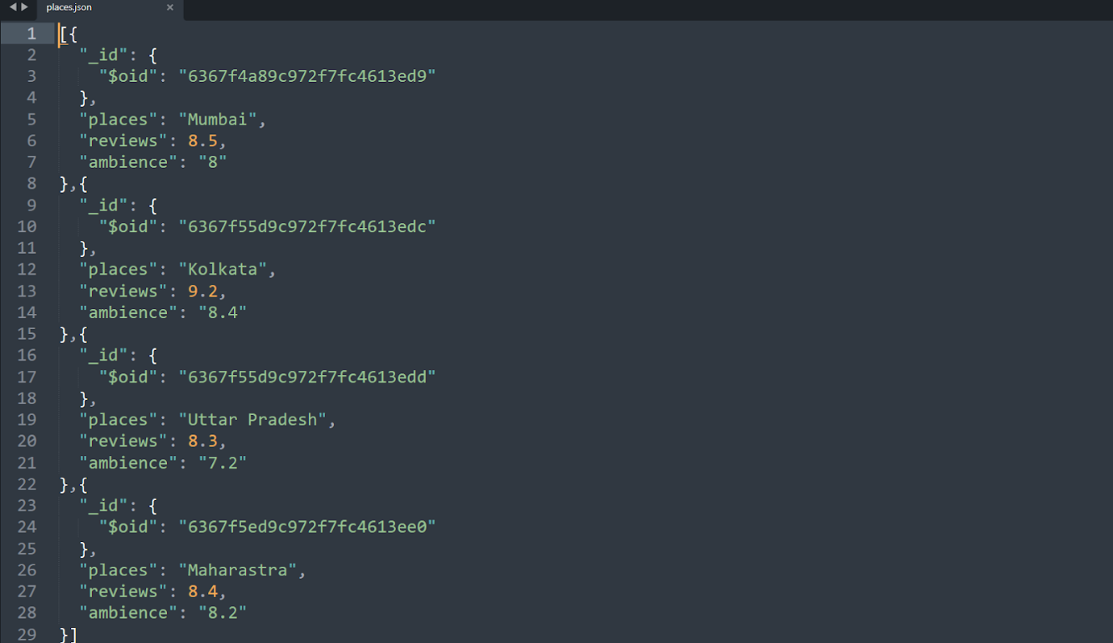

Figure 4.8: **JSON Data**

**4.3.5 Building the Model**

The next part is building the model. There are six steps in building the model that are constructing the training image generator for augmentation, the base model with KNN algorithm, adding model parameters, collecting the model, coaching the model, and there- fore the last is saving the model for the long run prediction method.

**4.3.6 Implementing the model**

The model enforced within the system. The trained data is then deployed using a framework. Various frameworks are there and its necessary to pick the optimal framework for the model. We have used a java script framework which takes request from the user and sends response with the data stored in the database. the data is then retrieved by the user and they have the option to edit the data and update it depending upon the reviews.

# CHAPTER 5 IMPLEMENTATION AND TESTING

## INPUT AND OUTPUT INPUT : -

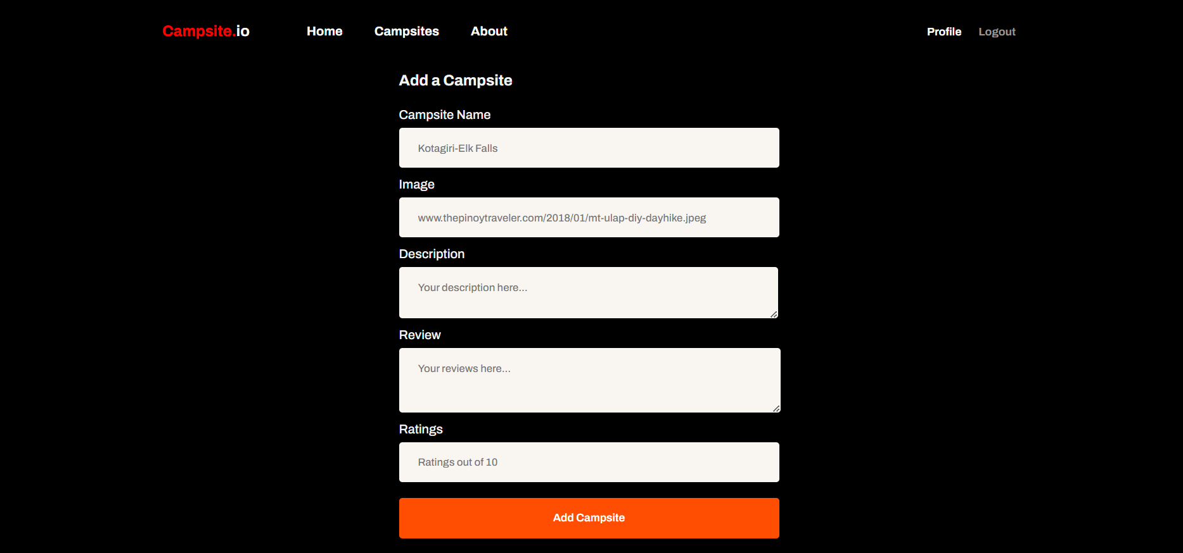

**OUTPUT : -**

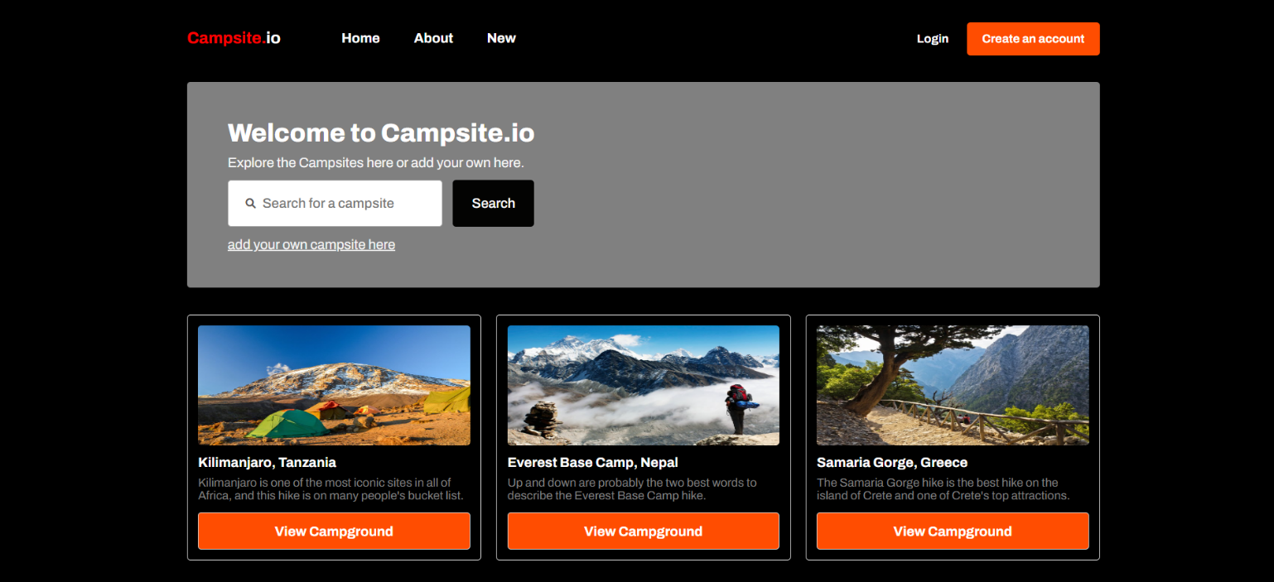

## TESTING

Testing is the process of evaluating a system or its component(s) with the intent to find whether it satisfies the specified requirements or not.

Software testing can be stated as the process of verifying and validating whether a software or application is bug-free, meets the technical requirements as guided by its design and development, and meets the user requirements effectively and efficiently by handling all the exceptional and boundary cases.

The process of software testing aims not only at finding faults in the existing software but also at finding measures to improve the software in terms of efficiency, accuracy, and usability. It mainly aims at measuring the specification, functionality, and performance of a software program or application.

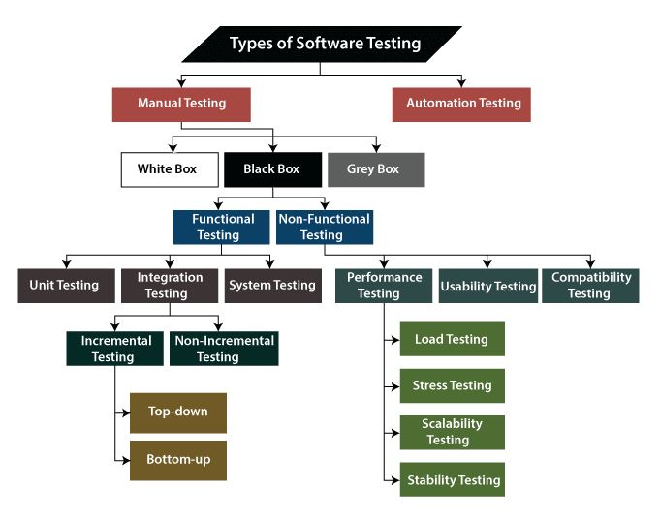

## 5.3 SAMPLE CODES

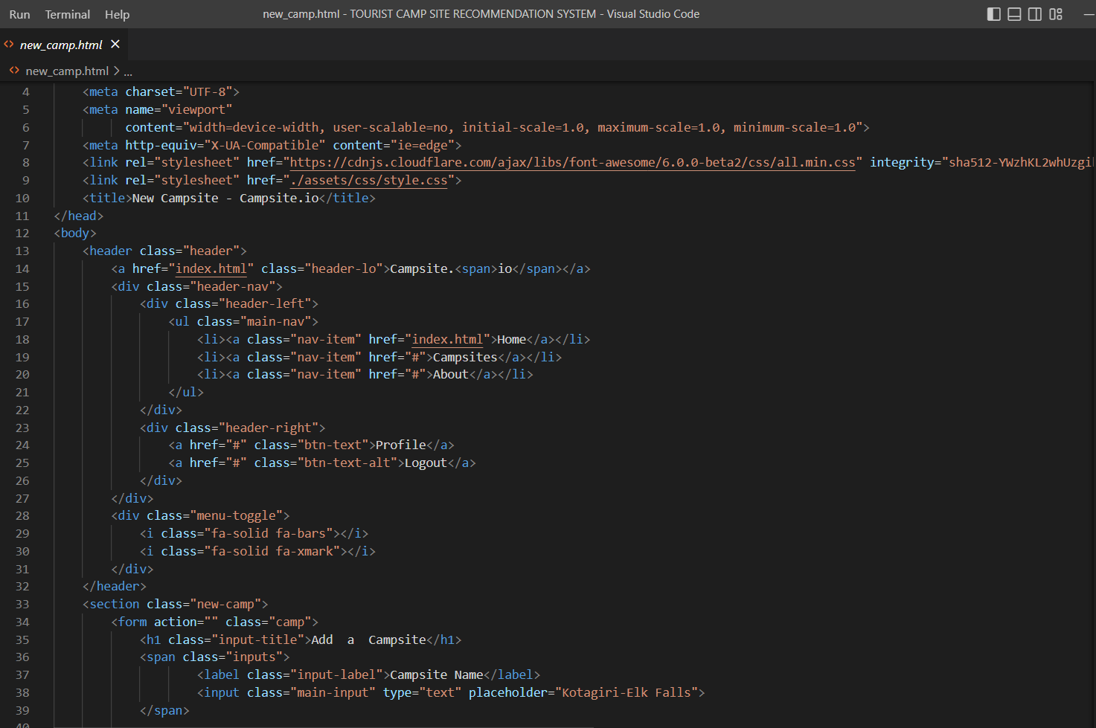

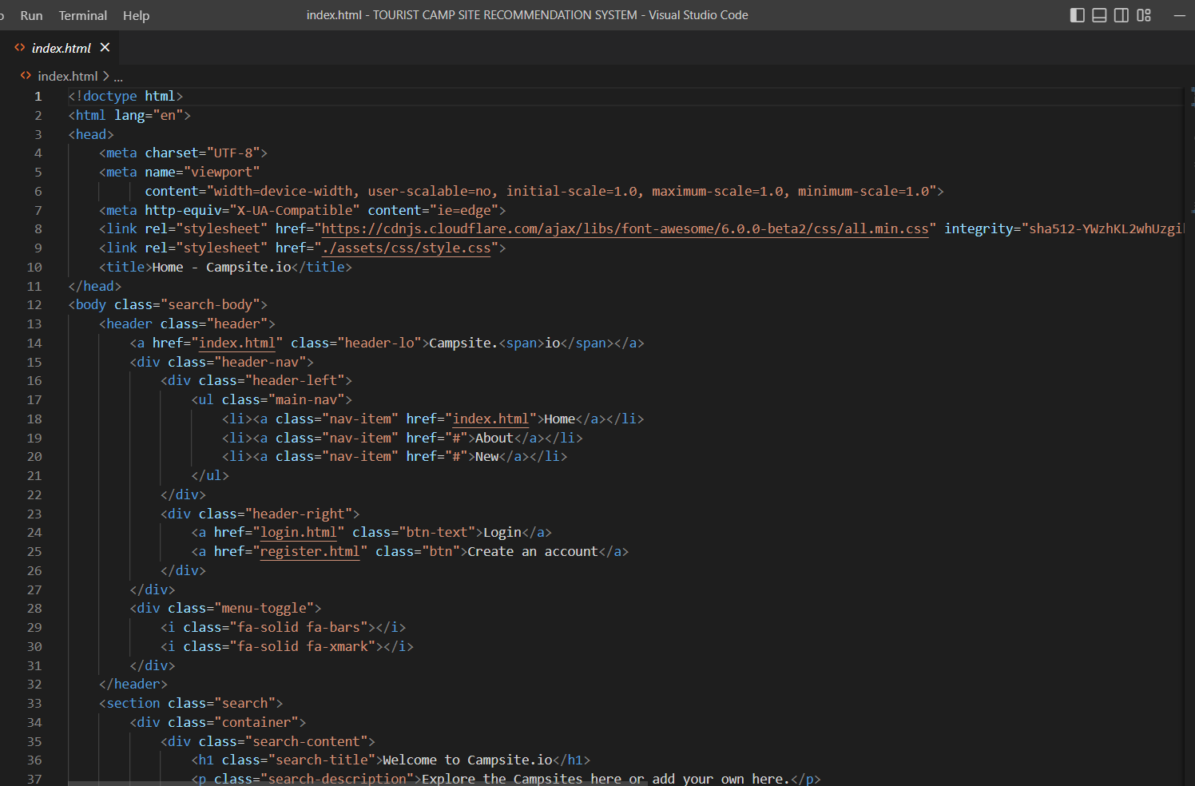

**5.4 TEST RESULT**

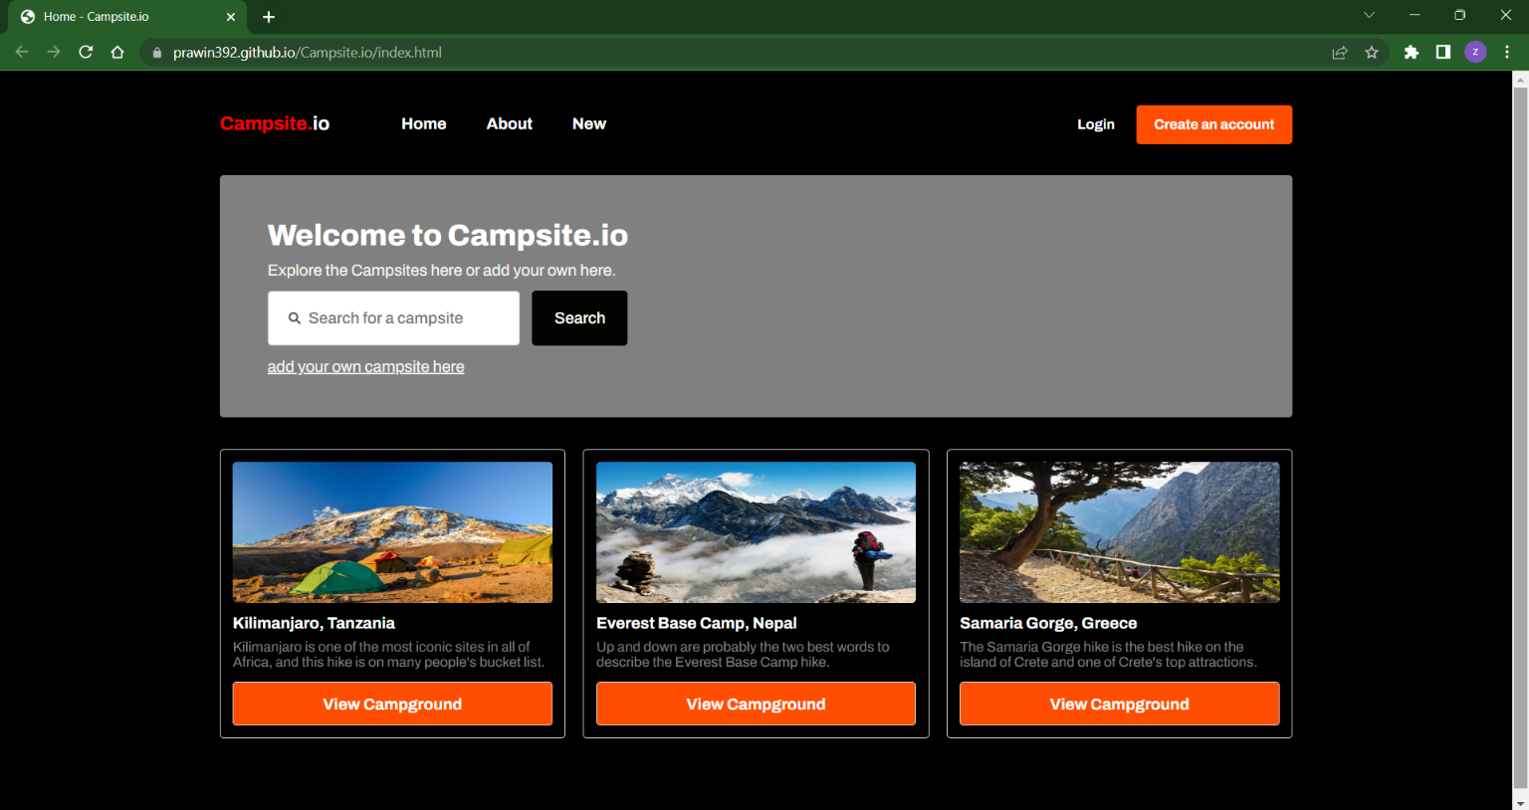

## 

# CHAPTER 6 RESULTS AND DISCUSSIONS

## EFFICIENCY OF PROPOSED SYSTEM

Camp site acts as a recommendation system. Users can send data and acquire data using the system. There is no need to store the data manually and it can be done virtually.The data is collected and then stored in easily extractable format.

Thanks to the need to store the data for a short while, camp site data can provide both alibis and incriminating data. camp site also provides security on a lower level, such as moderation to ensure that no heavy sided reviews are being commented.

A recommendation system, based on an unsupervised learning algorithm, has been proposed in a study. We use the algorithm to split the data into train and test. The trained data is used to recommend camps. The data is stored in a database and can be collected using cloud methods.

Camp site acts as a recommendation system. Users can send data and acquire data using the system. There is no need to store the data manually and it can be done virtually.The data is collected and then stored in easily extractable format.

We have added additional features to ensure that the camp site is publicized to the audience and events are conducted to promote the camp site.

The data is encrypted and cannot be easily accessed by third party users. Authentication is required to access the camp site and we have also improved the efficiency of the algorithm. The proposed system works on a much efficient level compared to other systems.

# CHAPTER 7

**SOURCE CODE IMPLEMENTATION & POSTER PRESENTATION**

## SOURCE CODE IMPLEMENTATION



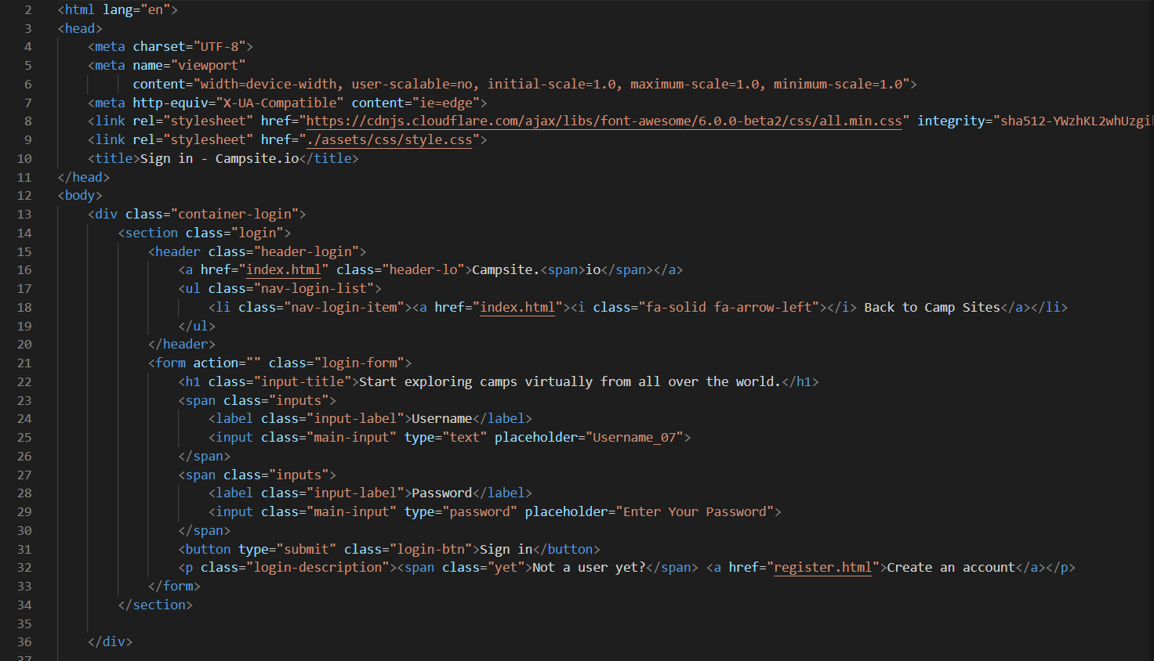

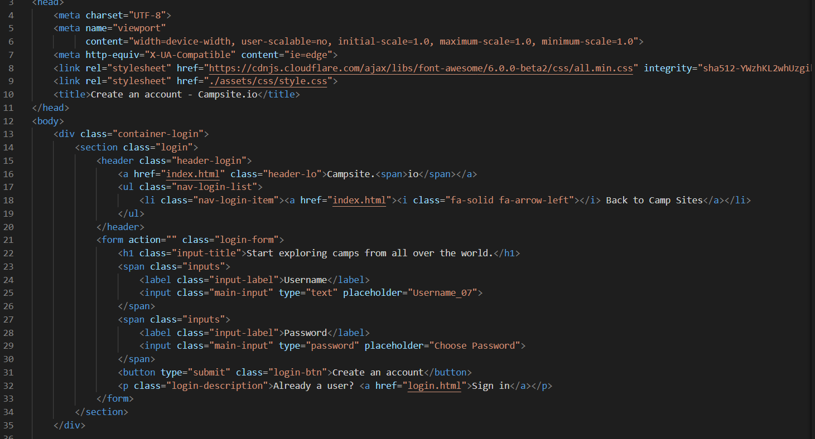

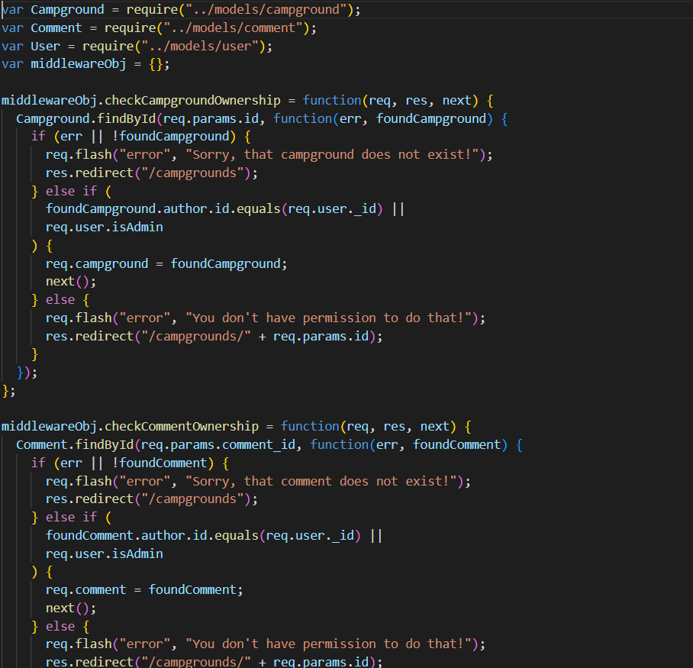

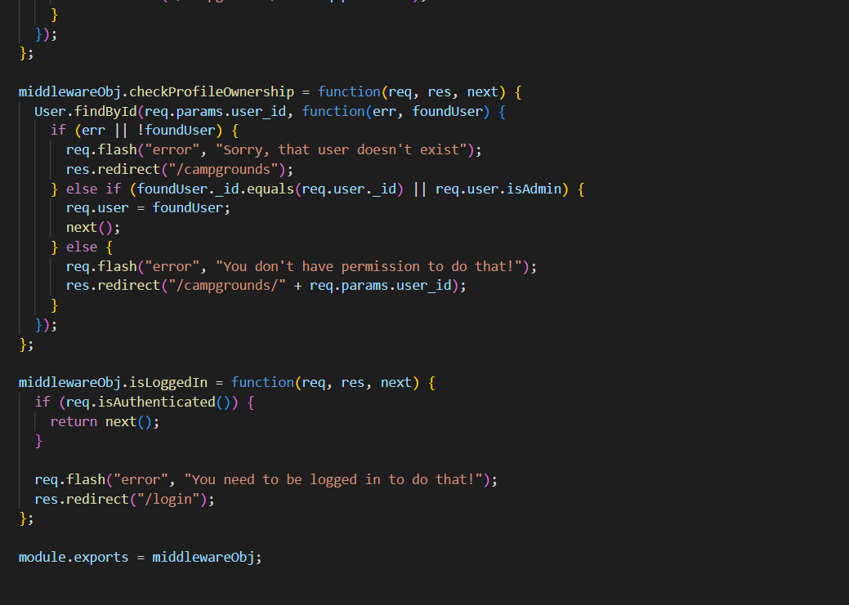

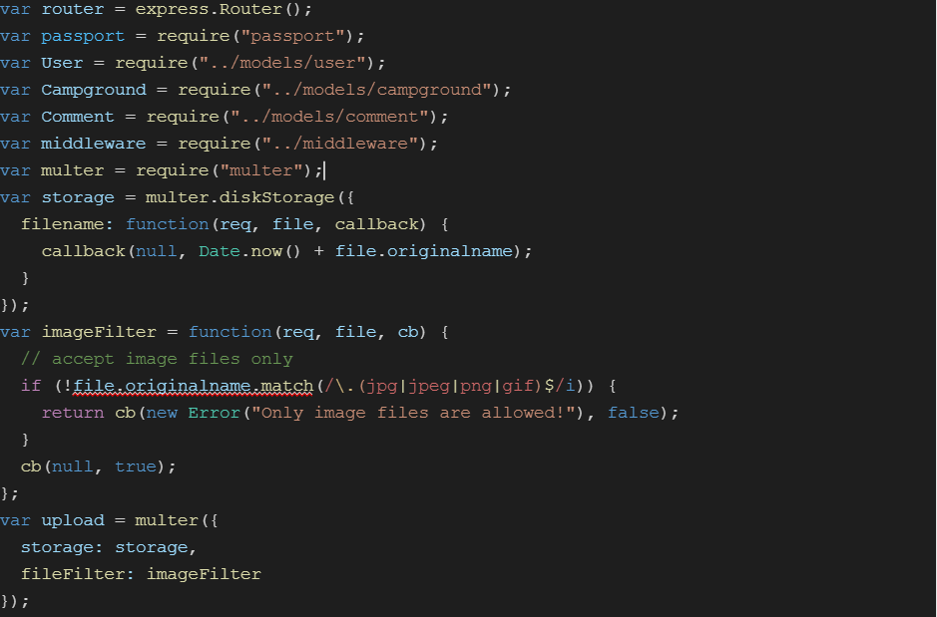

**OUTPUT: -**

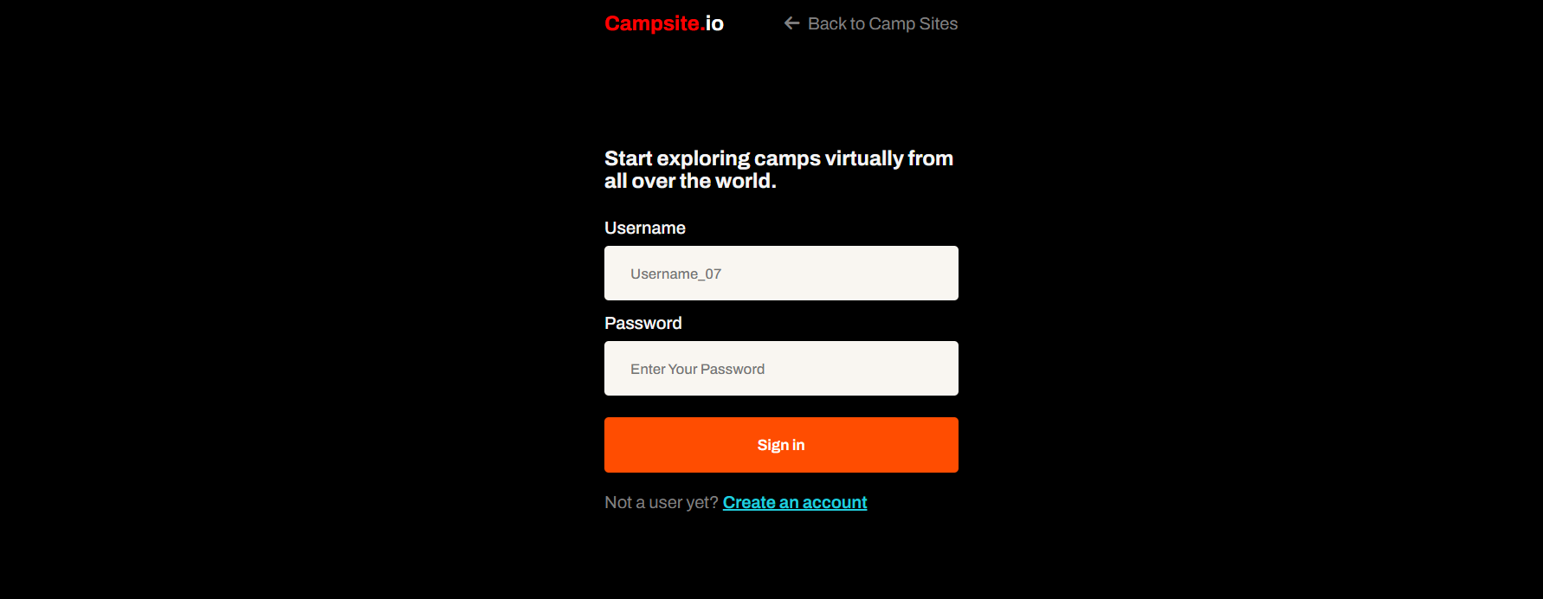

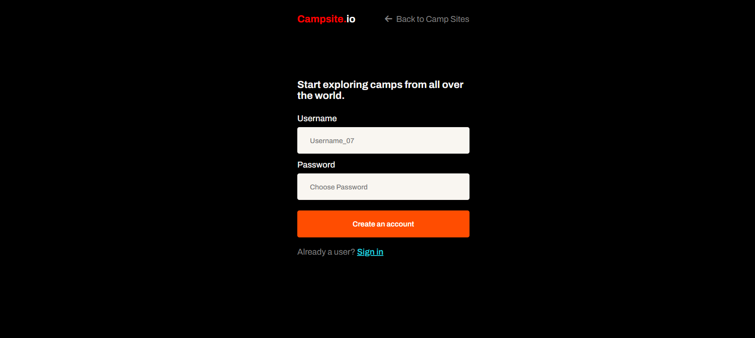

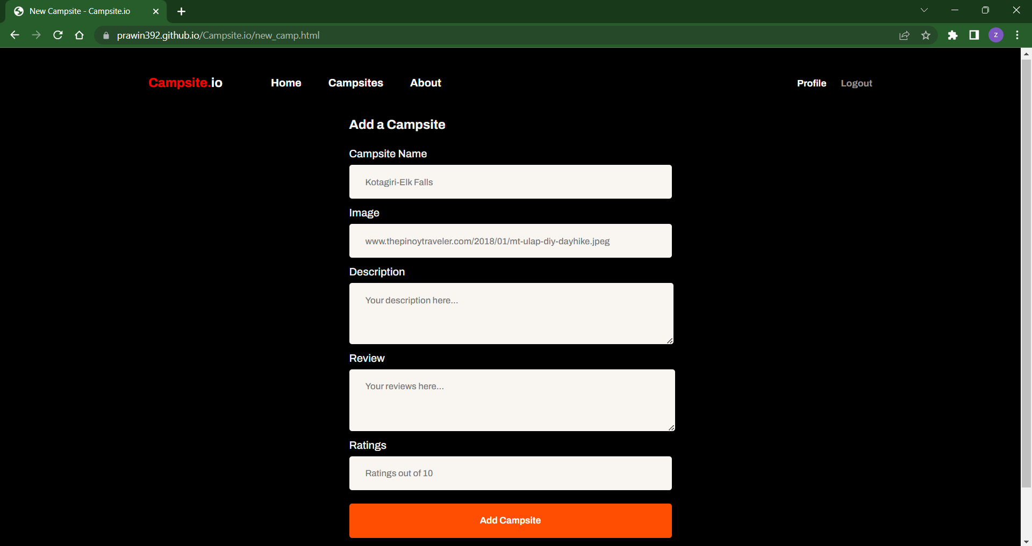

* 1. **POSTER PRESENTATION**



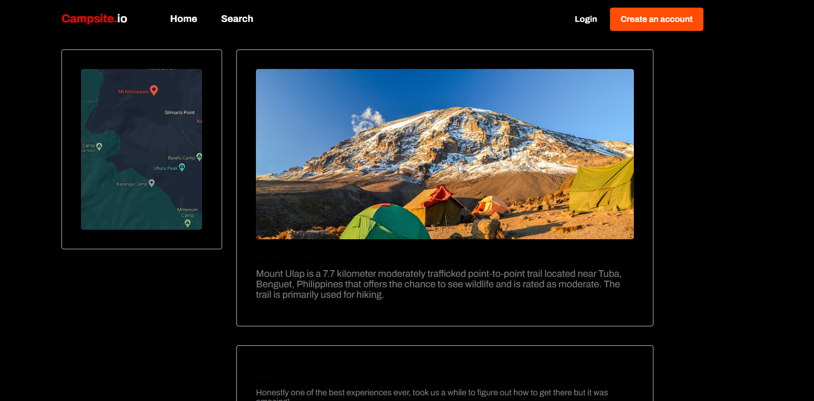







# CHAPTER 8

**CONCLUSION AND FUTURE ENHANCEMENTS**

## CONCLUSION

We conclude that by using machine learning techniques validating the usage and detection of data from user using machine learning, with this we can recommend the camp site places in areas for people interested. In proposed camp site recommendation system, the training and testing data sets are implemented successfully by categorizing places based on information provided by the user who had previously visited that place, it is the important factor in the implementation. The accuracy of the proposed model was good and can be implemented at any time.

This camp site system works quite well however, there is still room for improvement. This system speed can be increased with highly trained algorithms. Which can be able to recommend accurate sites. The use of algorithms let us to optimise the data and enable recommendations.

At present there are certain limits on parameters like locations, prohibited areas, overseas in the data, which can be removed by enhancing the algorithms further. This project is not a massive project and is indeed targeted to a selected audience.

Although some work exists for camp site recommendation system, the proposed research work is, therefore, targeting the identification and visualization of the South Asia region and the collected data is highly confined to the deeper parts of south asia.

Project can be updated in near future as and when requirement for the same arises, as it is very flexible in terms of expansion. Since this is a seasonal project, the requirement differs periodically over various seasons.

## 8.2 FUTURE ENHANCEMENTS

This project is only limited to some states in India but can be increased to other states in India to increase number of camp site places. The selection of states is very limited due to the fact that this project is not widely popular and is only active during seasonal months.

This project is only present in India and is expected to be used in other countries in the future for people who prefer camp sites in foreign countries. The reason being that the work is currently done by a small team and adding more workload will hinder the productivity of the team.

We intend to increase the number of user data input in the future with different types of ways. Now, the data is being collected only from the users, but in the future, we will try to get data across multiple ways.

The project has a very vast scope in future. The project can be implemented with more efficiency in  the future. The cost estimation will be taken care and we will increase the market using business ways.

Project can be updated in near future as and when requirement for the same arises, as it is very flexible in terms of expansion. Since this is a seasonal project, the requirement differs periodically over various seasons.

**REFERENCES**

1. Xiaoyue Jia, Fengchun Liu, Research on intelligent recommendation system model supported by data mining and algorithm optimization , 2021 IEEE International Conference on Emergency Science and Information Technology (ICESIT), 2022
2. Huawen Zhao, Yanhua Liu, Xiaohong Ling, Design of Intelligent Film and Television Advertisements Recommendation System Based on Digital Media and Decision Tree, 2021 6th International Conference on Communication and Electronics Systems (ICCES), IEEE, 2022
3. Hao Chang; Wei Wu, Xiaodong Shu, Ziqi Dong, Zhongchen Liu, Juhai Weng , Application of Content Based Recommendation System in Homestay, 2021 International Conference on Intelligent Transportation, Big Data & Smart City (ICITBS), IEEE, 2021
4. Chetan J. Awati, Suresh S. Shirgave, Veera S. Raval, Accurate Answers Selection and Expert Recommendation in Community Question Answers System, 2021 5th International Conference on Intelligent Computing and Control Systems (ICICCS), IEEE, 2021
5. Vyshnavi Garipelly, Padma Teja Adusumalli, Priyanka Singh, Travel Recommendation System Using Content and Collaborative Filtering - A Hybrid Approach, 2021 12th International Conference on Computing Communication and Networking Technologies (ICCCNT), IEEE, 2021
6. Rui Jiang, Hua Jiang, Personalized Cruise Travel Recommendation System Based on Data Mining and GLONASS Tools, 2022 4th International Conference on Smart Systems and Inventive Technology (ICSSIT), IEEE, 2022
7. Yang Zhou, A Dynamically Adding Information Recommendation System based on Deep Neural Networks, 2020 IEEE International Conference on Artificial Intelligence and Information Systems (ICAIIS), IEEE, 2020
8. Pranesh Ulleri, Shilpa Hari Prakash, Kiran B Zenith, Gouri S Nair Music Recommendation System Based on Emotion, 2021 12th International Conference on Computing Communication and Networking Technologies, IEEE, 2020